Effect of diesel-ethanol blends as fuels on performance and emissions of a diesel truck engine

Nhinh Nguyen Van*, Tuan Pham Minh, Tuyen Pham Huu
Hanoi University of Science and Technology, Vietnam
* huynhinhutehy@gmail.com
Keywords: Biofuels, ethanol-diesel blends, emissions, diesel engine.
Introduction
Recently, the alternative fuels have been widely researched and applied on internal combustion engine in many countries in all over the world because of fossil fuels limit and strict emission regulations. Among biofuels, ethanol is one of a potential alternatives that is normally used for spark ignition engines and also possible for diesel engines. This paper presents an experimental research on performance and emissions of Hyundai D4BB diesel engine truck using diesel-ethanol blends with different ratio of ethanol which are ED5 (95% diesel and 5% ethanol) and ED10 (90% diesel and 10% ethanol) at wide open throttle. The results show that there is a minor change in engine torque and fuel consumption, while HC and CO emissions and opacity reduce quite clearly, but NOx emissions increase a bit when using ethanol-diesel blends as compared to conventional diesel.
Experiment
The test is conducted in order to assess engine performance and emission characteristics when using a mixture of diesel fuel and ethanol at different ratios. Basic fuel is conventional diesel 0.05% S according to TCVN 5689-2005 available in Vietnam market.
The test engine is a Hyundai D4BB diesel engine. This is a four-stroke, four-cylinder, non-turbocharged engine mounted on a 1.25 ton Hyundai. The experiments were carried out at the Internal Combustion Engine Laboratory, Hanoi University of Science and Technology (Figure 1).
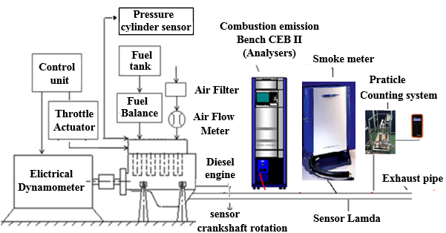
Figure 1. Experimental setup

Results and Conclusions

The torque and particle count are measured in the speed range of 1000 (rpm) to 3500 (rpm) and HC, CO, NOx, soot emissions are measured in units of ppm and are compared in all fuels

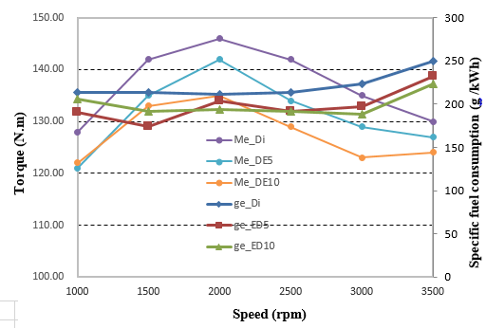Figure 2. Specific fuel consumption and torque when using diesel fuel, ED5, ED10.
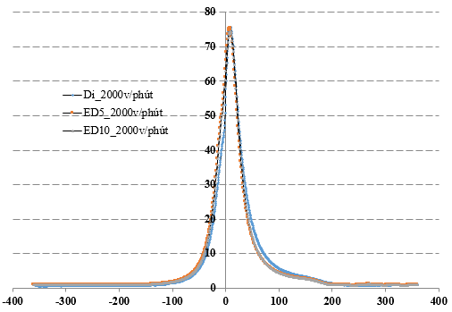Figure 4. Variable pressure in the cylinder when using diesel, ED5, ED10 at 2000 rpm.
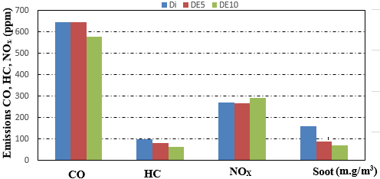
Figure 3. Average CO, HC, NO_{x}, Soot emissions when using diesel fuel, ED5, ED10.
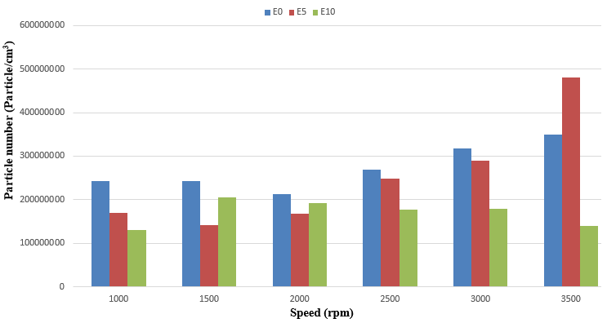
Figure 5. The number of particles in the speed range when using diesel fuel, ED5, ED10

The results show that the use of ED5 and ED10 as alternative fuels for existing diesel engines will reduce emissions. It can also be seen that the number of particles in the exhaust gas increases with ED5 but decreases with ED10 compared to the use of diesel fuel.
References
D.C. Rakopoulos, et al, “Effects of ethanol–diesel fuel blends on the performance and exhaust emissions of heavy duty DI diesel engine”, Energy Conversion and Management, Vol 49 pp. 3155–3162, 2008
Irshad Ahmed, “Oxygenated diesel: emissions and performance characteristics of ethanol-diesel blends in CI engines”, SAE 2001-01-2475
Jon Andersson, et al. (2007), Particle measurement Programme (PMP), Light duty inter-laboratory correlation exercise (ILCE_LD) final report, GRPE-PMP-18-2.

